**ITC 211 Systems Analysis**

**Fintan Guckian**

**SID 11630129**

**Assignment 2: Requirements Gathering**

**Stakeholder diagram**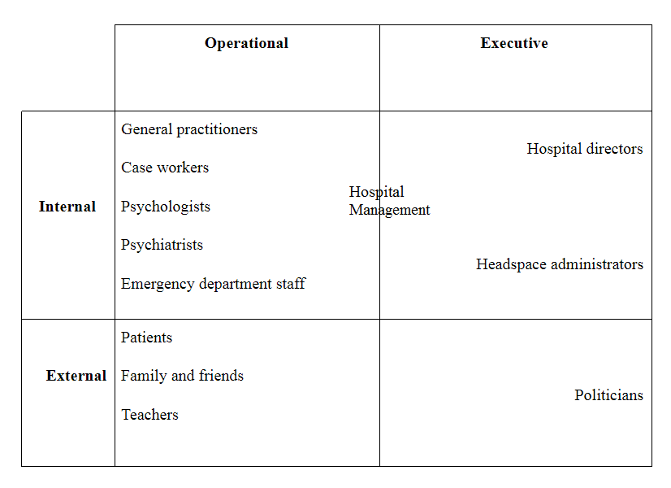

**Stakeholder interest**

Considering internal, operational stakeholders we find the many mental health workers that may be involved in treating a headspace patient. The main benefit these users would gain from the system is an enhanced ability to perform their work with the more detailed information this system will provide. Psychologists, psychiatrists and case workers can save time and work more effectively if they build on from the work of previous professionals rather than starting from scratch. GP’s and emergency department staff can use the background information to make crucial decisions about a patient, such as whether a patient needs to be committed for their own safety.

Looking at the internal executive quadrant we find the executives of both the hospitals and headspace administrators. A clear benefit for this quadrant is the time saved by their operational staff not needing to re-introduce a patient to the system with each new face. If patients are treated more effectively, statistical improvements reflect well on its administrators of both the hospital and headspace.

In the external, operational quadrant we find the personal benefits of the new system. These actors all have a deep personal interest in the patient receiving more effective treatment and are almost certainly the most at stake in the system. Seeing a loved one recover from debilitating mental health problems is probably the strongest reason for the existence of this new system and headspace itself.

Finally, in the external executive quadrant we find the politicians. These actors control funding and are answerable to the public for the mental health system as a whole. They monitor the system to see if it should receive more funding, remain the same or have its funding cut. They can win or lose public support based on the decisions they make and what happens under their watch.

**Headspace Questionnaire**

This questionnaire is being sent to emergency department staff in several hospitals that work in coordination with Headspace. Headspace is currently developing a system to facilitate communication between mental health professionals. Emergency department staff are viewed as being in a unique position to help young mental health patients.

The purpose of this questionnaire is to engage with emergency department staff to gain insight which will help to develop system requirements. We may engage participants at a later date to elaborate on their responses.

**Please answer these questions based on your experience with young mental health patients:**

I contact a patient's headspace case worker to inform them of their patient's release from the emergency department:

Never 1 2 3 4 5 Always

I find it easy to contact a patient’s headspace caseworker when I need to inform them of something concerning their patient:

Strongly Disagree 1 2 3 4 5 Strongly Agree

How do you contact a patient's headspace case worker?____________________________

I think it is important for a patient's headspace case worker to be notified when a patient is released from hospital:

Strongly Disagree 1 2 3 4 5 Strongly Agree

I find patients are often reticent to discuss details of the mental health history:

Strongly Disagree 1 2 3 4 5 Strongly Agree

More background information about a patient would help me do my job more effectively:

Strongly Disagree 1 2 3 4 5 Strongly Agree

I can contribute important information that could aid other health care professionals in helping a patient:

Strongly Disagree 1 2 3 4 5 Strongly Agree

I think there is effective communication between mental health professionals concerning a shared patient:

Strongly Disagree 1 2 3 4 5 Strongly Agree

Better modes of communication between mental health professionals would help me do my job more effectively:

Strongly Disagree 1 2 3 4 5 Strongly Agree

I feel comfortable using modern technology, such as applications, in the workplace:

Strongly Disagree 1 2 3 4 5 Strongly Agree

**Use case diagram and descriptions**

|  |  |
| --- | --- |
| **Use Case** | **Brief Use Case Description** |
| *Create headspace administrators profile* | Headspace administrator enters an administrator’s name email and role and the system assigns the administrator an authorised person’s key. |
| *Create a headspace caseworker profile* | Headspace administrator enters a caseworker's name, email and role and the system assigns the caseworker an authorised person’s key. |
| *Create a professional profile* | Headspace worker/professional enters the name, email and role of the professional and patient key. The system assigns an authorised person key for that professional and adds that key to patient's list of authorised patients. If a professional other than the headspace worker creates the profile, the system will require the headspace caseworkers approval. |
| *Create patient profile* | Headspace worker enters a patient's name, headspace caseworkers authorised person key, contact information of patient and close friends/family, initial story, list of authorised persons keys and patient status and the system creates a patient profile with a story record, list of professionals record and a current status and assigns the profile a patient key. |
| *Add a professional to patient profile* | Headspace worker/professional enters the authorised person’s key and patient’s key and the system saves that professional to the patient profile. If a professional other than a headspace case worker adds someone the system will require headspace workers approval. |
| *Look up patient* | Headspace worker/professional enters authorised key and the system retrieves the profiles of all the patients profiles that they have authorisation to view. |
| *Add information* | Headspace worker/professional adds information to patient story and the system records the contribution, the name of the author and the time of the contribution and email’s all authorised professionals on the patient’s profile to inform them of the changes. |
| *Change status* | Headspace worker/professional changes patient status between low risk, medium risk and high risk of self harm and the system holds that status and emails all authorised professionals on the patient's profile to inform them of the change. |
| *Contact professional* | Headspace worker/professional enters a message and the receiving professional’s authorised persons key and the system places the message in the receiver’s inbox and sends an email notification to the receiver informing them that they have a new message. |
| *Prompt for update* | Headspace case worker is prompted by the system via email to update patient profile if the profile has not been updated for one month. If the patient is a high risk the system will prompt for daily updates. |
| *Delete patient* | Headspace caseworker enters patient key and system archives patient profile. |
| *Delete Headspace caseworker* | Headspace administrator enters caseworkers authorised person key and the system archives caseworkers profile. |
| *Delete professional* | Headspace caseworker enters professionals authorised person key and the system archives the professional’s profile. |
| *Remove professional from patient profile* | Headspace caseworker enters authorised person’s key and patients key and the system removes professional from the patient’s file |

|  |  |
| --- | --- |
| Use case name: | *Create patient profile* |
| Scenario: | Headspace caseworker wants to add a new patient to the system. |
| Triggering event: | New patient becomes involved in the headspace program. |
| Brief description. | Headspace worker creates a new patient profile by entering the patient's name, headspace caseworkers authorised person key, contact information of patient and close friends/family, initial story, list of authorised persons keys (if there are initially any other professionals involved in the case) and the patient status. |
| Actors: | Patient, Headspace caseworker |
| Related use cases: | The *Create headspace caseworker* use case must be invoked to allow a caseworker to add patients. *Create a professional profile, Add a professional to patient profile, Look up patient, Add information, Change status, Contact professional* all require that this use case to be carried out as a prerequisite to their own invocation. |
| Stakeholders: | Patient, Headspace caseworker, Professionals. |
| Preconditions: | Headspace information subsystem must be available. Headspace caseworker must be authorised. |
| Postconditions | Patient profile must be saved.  Patient name must be saved.  Caseworkers authorised person key must be saved.  Contact information of patient and patient's family and friends must be saved.  Initial story must be saved.  List of authorised person’s keys must be saved.  Patients status must be saved. |
| Flow of activities: | |  |  | | --- | --- | | **Actor** | **System** | | 1.Headspace caseworker enters their authorised person key  2. Headspace caseworker indicates desire to create new patient  3. Headspace caseworker enters patient name, contact details, initial story and status  4. Headspace caseworker enters authorised persons key for other involved professionals | 1.1 System verifies authorisation key  1.2 System logs in authorised person and opens their profile.  2.1 System verifies that authorisation key belongs to a Headspace case worker  3.1 System creates new patient  3.2 System assigns patient with new patient key  3.2 System associates patient with caseworker  4.1 Systems verifies the authorised person’s key is valid.  4.2 System associates patient with professional. | |
| Exception conditions: | 1.1 Authorised persons key is invalid.  2.1 Authorised persons key does not belong to a Headspace case worker.  3.1 Data fields are incomplete.  4.1 Authorised persons key is invalid |

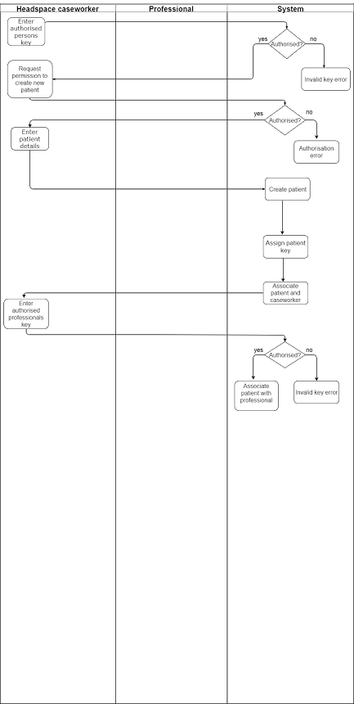

**References**

# Kupe Kupersmith, Paul Mulvey, Kate McGoey(n.d). How to Use Process Decomposition Diagrams. In Your Business Analysis Report in *Business Analysis For Dummies*

Retrieved from http://www.dummies.com/business/business-strategy/how-to-use-process

-decomposition-diagrams-in-your-business-analysis-report/

Satzinger, J.W., Jackson, R.B., & Burd, S.D. (2012). Introduction to System Analysis and Design: An Agile, Iterative Approach, 6e. Delhi: Course Technology, a part of Cengage Learning

Headspace. (2012) How Headspace can help. Retrived from https://web.archive.org/web/20120227171940/http://www.headspace.org.au/media/258650/how%20headspace%20can%20help%20%20fa%20web.pdf